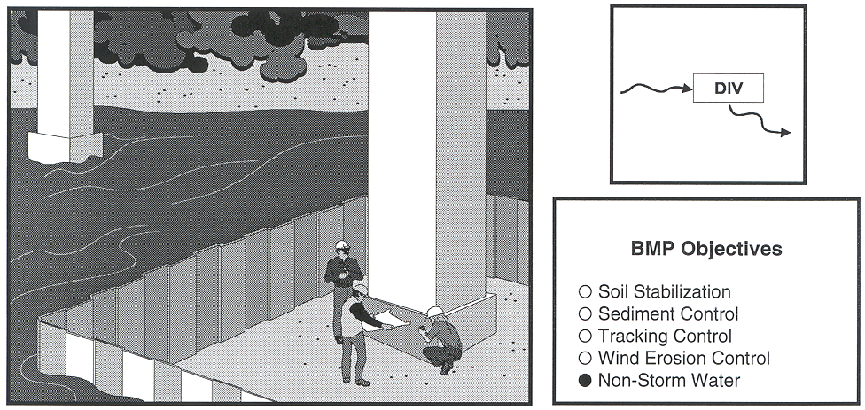  Definition and  ○  ○  ○  ○  ●  ○  Standard Symbol  Purpose | Clear water diversion consists of a system of structures and measures that intercept clear surface water runoff upstream of a project site, transport it around the work area, and discharge it downstream with minimal water quality degradation for either the project construction operations or the construction of the diversion. Clear water diversions are used in a waterway to enclose a construction area and reduce sediment pollution from construction work occurring in or adjacent to water. Isolation techniques are methods that isolate near shore work from a waterbody. Structures commonly used as part of this system include diversion ditches, berms, dikes, slope drains, rock, gravel bags, wood, sheet piles, aqua barriers, cofferdams, filter fabric or turbidity curtains, drainage and interceptor swales, pipes, or flumes.
Appropriate  Applications | - A clear water diversion is typically implemented where appropriate permits (1601 Agreement, 404 Permits, and 401 Water Quality Certifications) have been secured and work must be performed in a live stream or water body.  - Clear water diversions are appropriate for isolating construction activities occurring within or near a water body such as streambank stabilization, or culvert, bridge, pier or abutment installation. They may also be used in combination with other methods, such as clear water bypasses and/or pumps.  - Pumped diversions are suitable for intermittent and low flow streams. Excavation of a temporary bypass channel, or passing the flow through a pipe (called a “flume”) is appropriate for the diversion of streams less than 6 m (20 ft) wide, with flow rates less than 2.8 m³/sec (99 ft³/sec).  - Clear water diversions incorporating clean washed gravel may be appropriate for use in salmon spawning streams.
Limitations | - Diversion/encroachment activities will usually disturb the waterway during installation and removal of diversion structures.  - Specific permit requirements or mitigation measures, such as the U.S. Army Corps of Engineers, California Department of Fish and Game, Federal Emergency Management Agency (FEMA), Regional Water Quality Control Board (RWQCB), etc. may be included in contract documents because of clear water diversion/encroachment activities.  - Diversion/encroachment activities may constrict the waterway, which can obstruct flood flows and cause flooding or washouts. Diversion structures should not be installed without identifying potential impacts to the stream channel.  - Diversion or isolation activities should not completely dam stream flow.  - Dewatering and removal may require additional sediment control or water treatment (See NS-2, “Dewatering Operations”).
Standards and  Specifications | General  - Implement guidelines presented in NS-17, Streambank Stabilization to minimize impacts to streambanks.  - Where working areas encroach on live streams, barriers adequate to prevent the flow of muddy water into streams shall be constructed and maintained between working areas and streams. During construction of the barriers, muddying of streams shall be held to a minimum.  - Diversion structures must be adequately designed to accommodate fluctuations in water depth or flow volume due to tides, storms, flash floods, etc.  - Heavy equipment driven in wet portions of a water body to accomplish work shall be completely clean of petroleum residue, and water levels shall be below the gearboxes of the equipment in use, or lubricants and fuels are sealed such that inundation by water shall not result in leaks.  - Mechanical equipment operated in the water shall not be submerged to a point above any axle of said mechanical equipment.  - Excavation equipment buckets may reach out into the water for the purpose of removing or placing fill materials. Only the bucket of the crane/ excavator/backhoe may operate in a water body. The main body of the crane/excavator/backhoe shall not enter the water body, except as necessary to cross the stream to access the work site.  - Clear water diversions that require dewatering shall be conducted in accordance with policies and guidelines presented in Field Guide to Construction Site Dewatering, October 2001, CTSW-RT-01-010.  - Stationary equipment such as motors and pumps, located within or adjacent to a water body, shall be positioned over drip pans.  - When any artificial obstruction is being constructed, maintained, or placed in operation, sufficient water shall, at all times, be allowed to pass downstream to maintain aquatic life downstream.  - The exterior of vehicles and equipment that will encroach on a water body within the project shall be maintained free of grease, oil, fuel, and residues.  - Equipment shall not be parked below the high water mark unless allowed by a permit.  - Disturbance or removal of vegetation shall not exceed the minimum necessary to complete operations. Precautions shall be taken to avoid damage to vegetation by people or equipment. Disturbed vegetation shall be replaced with the appropriate soil stabilization measures.  - Riparian vegetation, when removed pursuant to the provisions of the work, shall be cut off no lower than ground level to promote rapid re-growth. Access roads and work areas built over riparian vegetation shall be covered by a sufficient layer of clean river run rock to prevent damage to the underlying soil and root structure. The rock shall be removed upon completion of project activities.  - Drip pans shall be placed under all vehicles and equipment placed on docks, barges, or other structures over water bodies when the vehicle or equipment is planned to be idle for more than one hour.  - Where possible, avoid or minimize diversion/encroachment impacts by scheduling construction during periods of low flow or when the stream is dry. See also the project special provisions for scheduling requirements. Scheduling shall also consider seasonal releases of water from dams, fish migration and spawning seasons, and water demands due to crop irrigation.  - Construct diversion structures with materials free of potential pollutants such as soil, silt, sand, clay, grease, or oil.  Temporary Diversions/Encroachments  - Construct diversion channels in accordance with BMP SS-9, “Earth Dikes/Drainage Swales, and Ditches.”  - In high flow velocity areas, stabilize slopes of embankments and diversion ditches using an appropriate liner, in accordance with BMP SS-7, “Geotextiles, Plastic Covers & Erosion Control Blankets/Mats”, or use rock slope protection, as described in Standard Specifications Section 72-2, “Rock Slope Protection.”  - Where appropriate, use natural streambed materials such as large cobbles and boulders for temporary embankment/slope protection, or other temporary soil stabilization methods.  - Provide for velocity dissipation at transitions in the diversion, such as the point where the stream is diverted to the channel and the point where the diverted stream is returned to its natural channel. See also BMP SS-10, “Outlet Protection/Velocity Dissipation Devices.”  Temporary Dry Construction Areas  - When dewatering behind temporary structures to create a temporary dry construction area, such as coffer dams, pass pumped water through a sediment settling device, such as a portable tank or settling basin, before returning water to the water body; See also BMP NS-2, “Dewatering Operations.”  - If the presence of polluted water or sediment is identified in the contract, the contractor shall implement dewatering pollution controls as required by the contract documents. If the quality of water or sediment to be removed while dewatering is not identified as polluted in the contract documents, but is later determined by observation or testing to be polluted, the contractor shall notify the Resident Engineer (RE) and comply with Standard Specifications Section 5-1.116 “Differing Site Conditions.”  - Any substance used to assemble or maintain diversion structures, such as form oil, shall be non-toxic and non-hazardous.  - Any material used to minimize seepage underneath diversion structures, such as grout, shall be non-toxic, non-hazardous, and as close to a neutral pH as possible.  Isolation Techniques:  Isolation techniques are methods that isolate near shore work from a waterbody. Techniques include sheet pile enclosures, water-filled geotextile (Aqua Dam) , gravel berm with impermeable membrane, gravel bags, coffer dams, and K-rail.  Filter Fabric Isolation Technique  Definition and Purpose:  A filter fabric isolation structure (See Figure 1-C) is a temporary structure built into a waterway to enclose a construction area and reduce sediment pollution from construction work in or adjacent to water. This structure is composed of filter fabric, gravel bags, and steel t-posts.  Appropriate Applications:  - Filter fabric may be used for construction activities such as streambank stabilization, or culvert, bridge, pier or abutment installation. It may also be used in combination with other methods, such as clean water bypasses and/or pumps.  - This method involves placement of gravel bags or continuous berms to “key-in” the fabric, and subsequently staking the fabric in place.  - If spawning gravel (gravel between 25 and 100 mm [1 and 4 inches]) is used, all other components of the isolation can be removed from the stream, and the gravel can be spread out and left as salmon spawning habitat. Whether spawning gravel or other types of gravel are used, only clean washed gravel should be used as infill for the gravel bags or continuous berm.  - This is a method that should be used in relatively calm water, and can be used in smaller streams.  Limitations  - Do not use if the installation, maintenance and removal of the structures will disturb sensitive aquatic species of concern.  - Not appropriate for projects where dewatering is necessary.  - Not appropriate to completely dam streamflow.  Standards and Specifications:  - For the filter fabric isolation method, a non-woven or heavy-duty fabric (refer to Standard Specifications Section 88) is recommended over standard silt fence. Using rolled geotextiles allows non-standard widths to be used.  - Anchor filter fabric with gravel bags filled with clean, washed gravel. Do not use sand. If a bag should split open, the gravel can be left in the stream, where it can provide aquatic habitat benefits.  - Another anchor alternative is a continuous berm, made with the Continuous Berm Machine. This is a gravel-filled bag that can be made in very long segments. The length of the berms is usually limited to 6 m (20 ft) for ease of handling.  Installation  - Place the fabric on the bottom of the stream, and place either a bag of clean, washed gravel or a continuous berm over the bottom of the fabric, such that a bag-width of fabric lies on the stream bottom. The bag should be placed on what will be the outside of the isolation area.  - Pull the fabric up, and place a metal t-post immediately behind the fabric, on the inside of the isolation area; attach the fabric to the post with three diagonal nylon ties.  - Continue placing fabric as described above until the entire work area has been isolated, staking the fabric at least every 1.8 m (6 ft).  Maintenance and Inspection:  - During construction, inspect daily during the workweek.  - Schedule additional inspections during storm events.  - Immediately repair any gaps, holes or scour.  - Remove sediment buildup.  - Remove BMP upon completion of construction activity. Recycle or re-use if applicable.  - Re-vegetate areas disturbed by BMP removal if needed.  Turbidity Curtain Isolation Technique  Definition and purpose:  A turbidity curtain (refer to Figures 1A through 1D) is a fabric barrier used to isolate the near shore work area. The barriers are intended to confine the suspended sediment. The curtain is a floating barrier, and thus does not prevent water from entering the isolated area; rather, it prevents suspended sediment from getting out.  Appropriate applications:  Turbidity curtains should be used where sediment discharge to a stream is unavoidable. They are used when construction activities adjoin quiescent waters, such as lakes, ponds, lagoons, bays, and slow flowing rivers. The curtains are designed to deflect and contain sediment within a limited area and provide sufficient retention time so that the soil particles will fall out of suspension.  Limitations:  - Turbidity curtains should not be used in flowing water; they are best suited for use in ponds, lakes, lagoons, bays, and very slow-moving rivers.  - Turbidity curtains should not be placed across the width of a channel.  - Removing sediment that has been deflected and settled out by the curtain may create a discharge problem through the re-suspension of particles and by accidental dumping by the removal equipment.  Standards and Specifications:  - Turbidity curtains should be oriented parallel to the direction of flow.  - The curtain should extend the entire depth of the watercourse in calm-water situations.  - In wave conditions, the curtain should extend to within 0.3 m (1 ft) of the bottom of the watercourse, such that the curtain does not stir up sediment by hitting the bottom repeatedly. If it is desirable for the curtain to reach the bottom in an active-water situation, a pervious filter fabric may be used for the bottom 0.3 m (1 ft).  - The top of the curtain should consist of flexible flotation buoys, and the bottom shall be held down by a load line incorporated into the curtain fabric. The fabric shall be a brightly colored impervious mesh.  - The curtain shall be held in place by anchors placed at least every 30 m (100 ft).  - First place the anchors, then tow the fabric out in a furled condition, and connect to the anchors. The anchors should be connected to the flotation devices, and not to the bottom of the curtain. Once in place, cut the furling lines, and allow the bottom of the curtain to sink.  - Sediment that has been deflected and settled out by the curtain may be removed if so directed by the on-site inspector or the RE. Consideration must be given to the probable outcome of the removal procedure. It must be asked if it will create more of a sediment problem through re-suspension of the particles or by accidental dumping of material during removal. It is recommended that the soil particles trapped by the turbidity curtain only be removed if there has been a significant change in the original contours of the affected area in the watercourse.  - Particles should always be allowed to settle for a minimum of 6 to 12 hours prior to their removal or prior to removal of the turbidity curtain.  Maintenance and Inspection:  - The curtain should be inspected daily for holes or other problems, and any repairs needed should be made promptly.  - Allow sediment to settle for 6 to 12 hours prior to removal of sediment or curtain. This means that after removing sediment, wait an additional 6 to 12 hours before removing the curtain.  - To remove, install furling lines along the curtain, detach from anchors, and tow out of the water.  K-rail River Isolation  Definition and Purpose:  This is temporary sediment control, or stream isolation method that uses K-rails (refer to Figure 2) to form the sediment deposition area, or to isolate the in-stream or near-bank construction area.  Barriers are placed end-to-end in a pre-designed configuration and gravel-filled bags are used at the toe of the barrier and also at their abutting ends to seal and prevent movement of sediment beneath or through the barrier walls.  Appropriate Applications:  - The K-rail isolation can be used in streams with higher water velocities than many other isolation techniques.  Limitations:  - The K-rail method does not allow for full dewatering.  Standards and Specifications:  - To create a floor for the K-rail, move large rocks and obstructions. Place washed gravel and gravel-filled bags to create a level surface for K-rail to sit.  - Place the bottom two K-rails adjacent to each other, and parallel to the direction of flow; fill the center portion with gravel bags. Then place the third K-rail on top of the bottom two; there should be sufficient gravel bags between the bottom K-rails such that the top one is supported by the gravel. Place plastic sheeting around the K-rails, and secure at the bottom with gravel bags.  - Further support can be added by pinning and cabling the K-rails together. Also, large riprap and boulders can be used to support either side of the K-rail, especially where there is strong current.  Maintenance and Inspection:  - The barrier should be inspected at least once daily, and any damage, movement or other problems should be addressed immediately.  - Sediment should be allowed to settle for at least 6 to 12 hours prior to removal of sediment, and for 6 to 12 hours prior to removal of the barrier.  Stream Diversions  Definition and Purpose:  Stream diversions consist of a system of structures and measures that intercept an existing stream upstream of the project and, transports it around the work area, and discharges it downstream (refer to Figure 3). The selection of which stream diversion technique to use depends upon the type of work involved, physical characteristics of the site, and the volume of water flowing through the project.  Appropriate Applications:  - Pumped diversions are appropriate in areas where de-watering is necessary.  - Dam-type diversions may serve as temporary access to the site.  - Where work areas require isolation from flows.  Limitations:  - Pumped diversions have limited flow capacity.  - Pumped diversion require frequent monitoring of pumps.  - Large flows during storm events can overtop dams.  - Flow diversion and re-direction with small dams involves in-stream disturbance and mobilization of sediment.  Standards and Specifications:  - Installation guidelines will vary based on existing site conditions and type of diversion used.  - Diversions shall be sized to convey design flood flows.  - Pump capacity must be sufficient for design flow; the upper limit is approximately 0.3 m³/sec (10 cfs) (the capacity of two 200 mm [8 inch] pumps).  - Adequate energy dissipation must be provided at the outlet to minimize erosion.  - Dam materials used to create dams upstream and downstream of diversion should be erosion resistant; materials such as steel plate, sheetpile, sandbags, continuous berms, inflatable water bladders, etc. would be acceptable.  - When constructing a diversion channel, begin excavation of the channel at the proposed downstream end, and work upstream. Once the watercourse to be diverted is reached, and the excavated channel is stable, breach the upstream end, and allow water to flow down the new channel. Once flow has been established in the diversion channel, install the diversion weir in the main channel; this will force all water to be diverted from the main channel.  Maintenance and Inspection:  - Inspect diversion/encroachment structures before and after significant storms, and at least once per week while in service. Inspect daily during the construction.  - Pumped diversions require frequent monitoring of pumps.  - Inspect embankments and diversion channels before and after significant storms, and at least once per week while in service for damage to the linings, accumulating debris, sediment buildup, and adequacy of the slope protection. Remove debris and repair linings and slope protection as required. Repair holes, gaps, or scour.  - Upon completion of work, the diversion or isolation structure should be removed and flow should be re-directed through the new culvert or back into the original stream channel. Recycle or re-use if applicable.  Instream Construction Sediment Control  There are three different options currently available for reducing turbidity while working in a stream or river. The stream can be; 1. isolated from the area in which work is occurring by means of a water barrier, 2. the stream can be diverted around the work site through a pipe or temporary channel, or 3. one can employ construction practices that minimize sediment suspension.  The highest hazard for sedimentation from instream construction generally occurs when the sediment control structure is being installed and when it is being removed. Generally the best time to install the stream isolation or diversion structure is when the stream is low. Conversly, the optimum time to remove in-stream diversion or isolation structures may be during the rising limb of a storm hydrograph. A probable “worst time” to release high TSS into a stream system with diminishing aquatic habitat might be when the stream is very low; summer low flow, for example. During these times, the flow may be low while the biological activity in the stream is very high. On the other hand, the addition of short-term spike in TSS or sediment during a big storm discharge might have a relatively low impact on the aquatic habitat or turbidity because the stream is already turbid, and the stream energy is capable of transporting both suspended solids, and large quantities of bedload through the system.  Techniques to minimize Total Suspended Solids (TSS)  - Padding - Padding laid in the stream below the work site may trap some solids that are deposited in the stream during construction. After work is done, the padding is removed from the stream, and placed on the bank to assist in revegetation.  - Clean, washed gravel - Using clean, washed gravel decreases solid suspension, as there are fewer small particles deposited in the stream.  - Excavation using a large bucket -Each time a bucket of soil is placed in the stream, a portion is suspended. Approximately the same amount is suspended whether a small amount of soil is placed in the stream, or a large amount. Therefore, using a large excavator bucket instead of a small one, will reduce the total amount of soil that washes downstream.  - Use of dozer for backfilling - Using a dozer for backfilling instead of a backhoe follows the same principles – the fewer times soil is deposited in the stream, the less soil will be suspended.  - Partial dewatering with a pump - Partially dewatering a stream with a pump reduces the amount of water, and thus the amount of water that can suspend sediment.  Washing Fines  Definition and Purpose:  Washing fines is an “in-channel” sediment control method, which uses water, either from a water truck or hydrant, to wash any stream fines that were brought to the surface of the channel bed during restoration, back into the interstitial spaces of the gravel and cobbles. This technique is useful in both intermittent or ephemeral stream channels with gravelly to cobbely substrate and may be useful in perennial streams just prior to removing isolation structures.  The purpose of this technique is to reduce or eliminate the discharge of sediment from the channel bottom during the first seasonal flows, or “first flush.” Sediment should not be allowed into stream channels; however, occasionally in-channel restoration work will involve moving or otherwise disturbing fines (sand and silt-sized particles) that are already in the stream, usually below bankfull discharge elevation. Subsequent re-watering (resumption of flows) of the channel can result in a plume of turbidity and sedimentation.  This technique washes the fines back into the channel bed. Bedload materials, including gravel cobbles, boulders and those fines, are naturally mobilized during higher storm flows. This technique is intended to delay the discharge until the fines would naturally be mobilized.  Appropriate Applications:  - This technique should be used when construction work is required in channels. It is especially useful in intermittent or ephemeral streams in which work is performed “in the dry”, and which subsequently become re-watered.  Limitations:  - The stream must have sufficient gravel and cobble substrate composition.  - The use of this technique requires consideration of time of year and timing of expected stream flows.  - The optimum time for the use of this technique is in the fall, prior to winter flows.  - Consultation with, and approval from the Department of Fish and Game and the Regional Water Quality Control Board may be required.  Standards and Specifications:  - Apply sufficient water to wash fines, but not cause further erosion or runoff.  - Apply water slowly and evenly to prevent runoff and erosion.  - Consult with Department of Fish and Game and the Regional Water Quality Control Board for specific water quality requirements of applied water (e.g. chlorine).

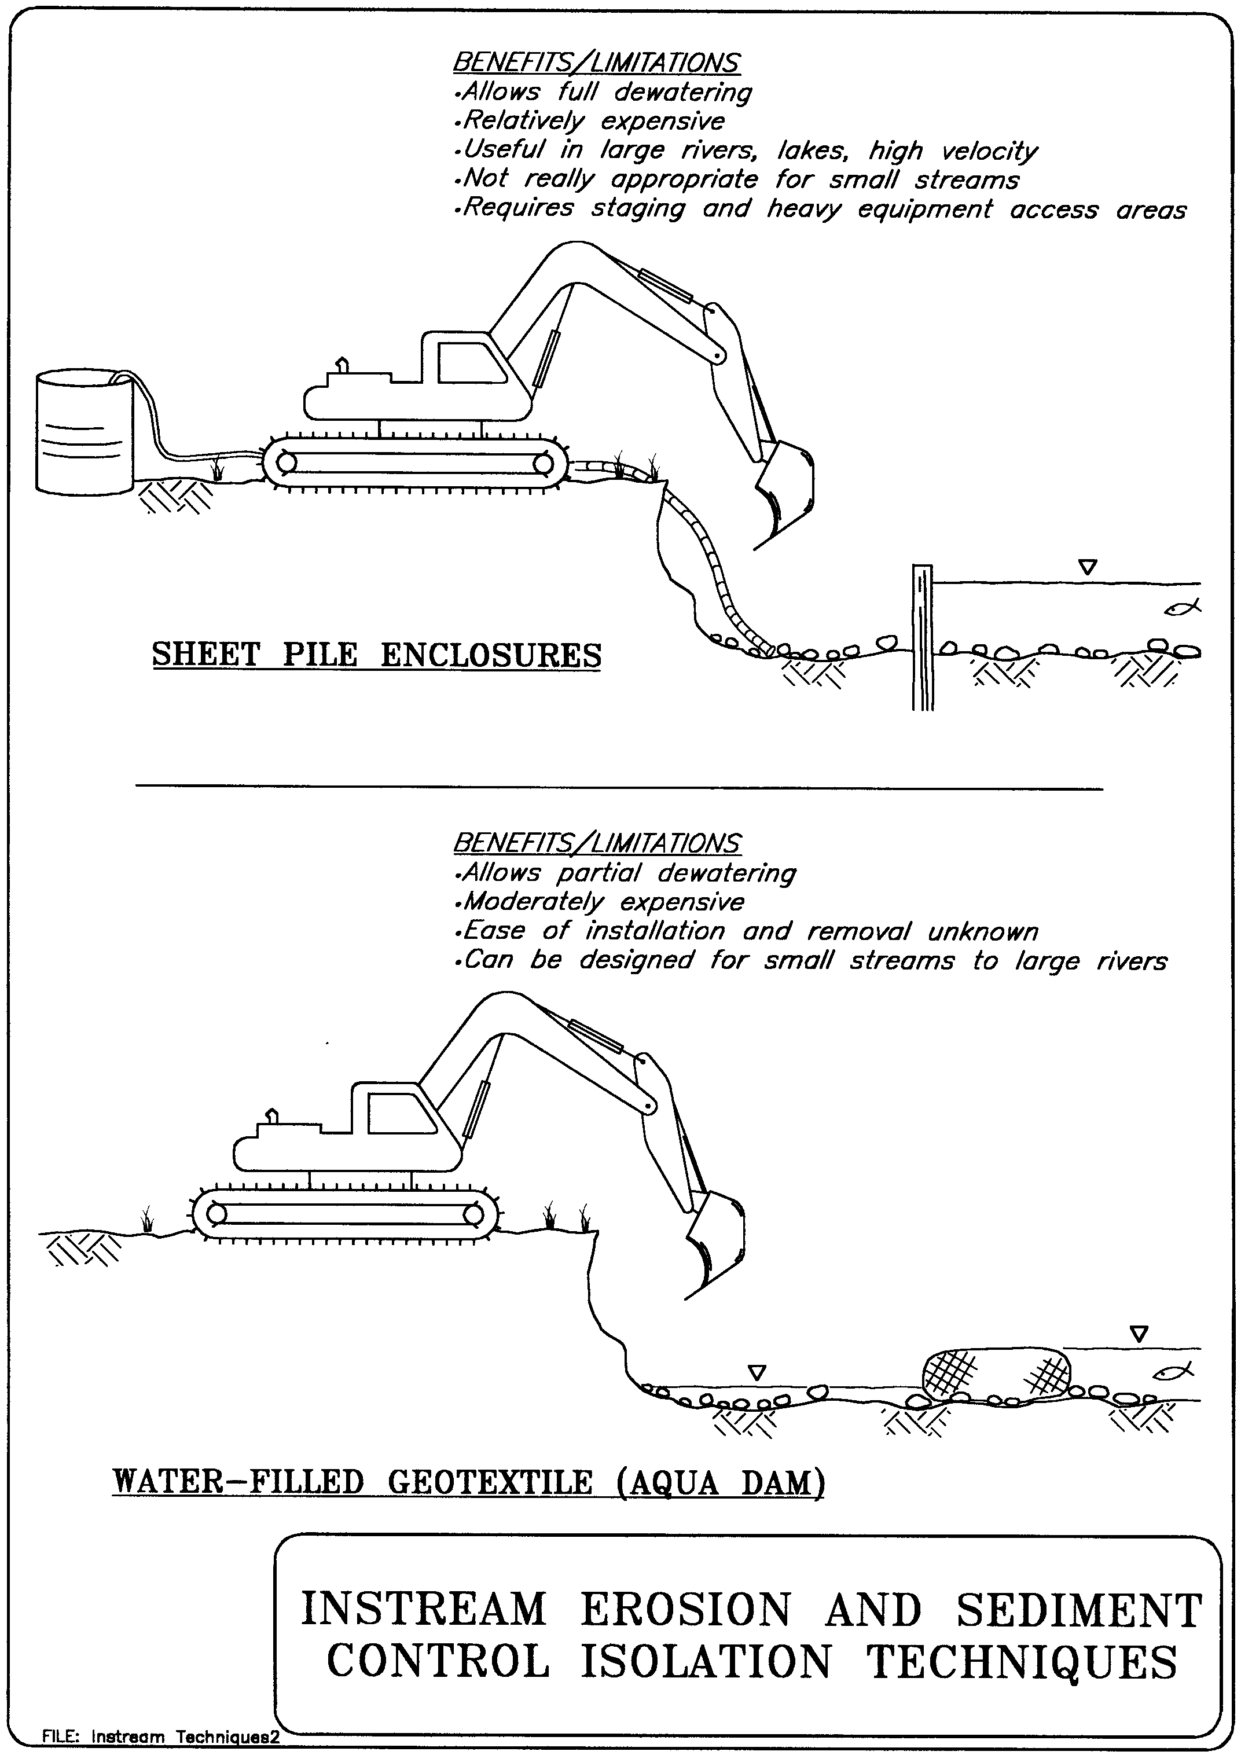

Figure 1A
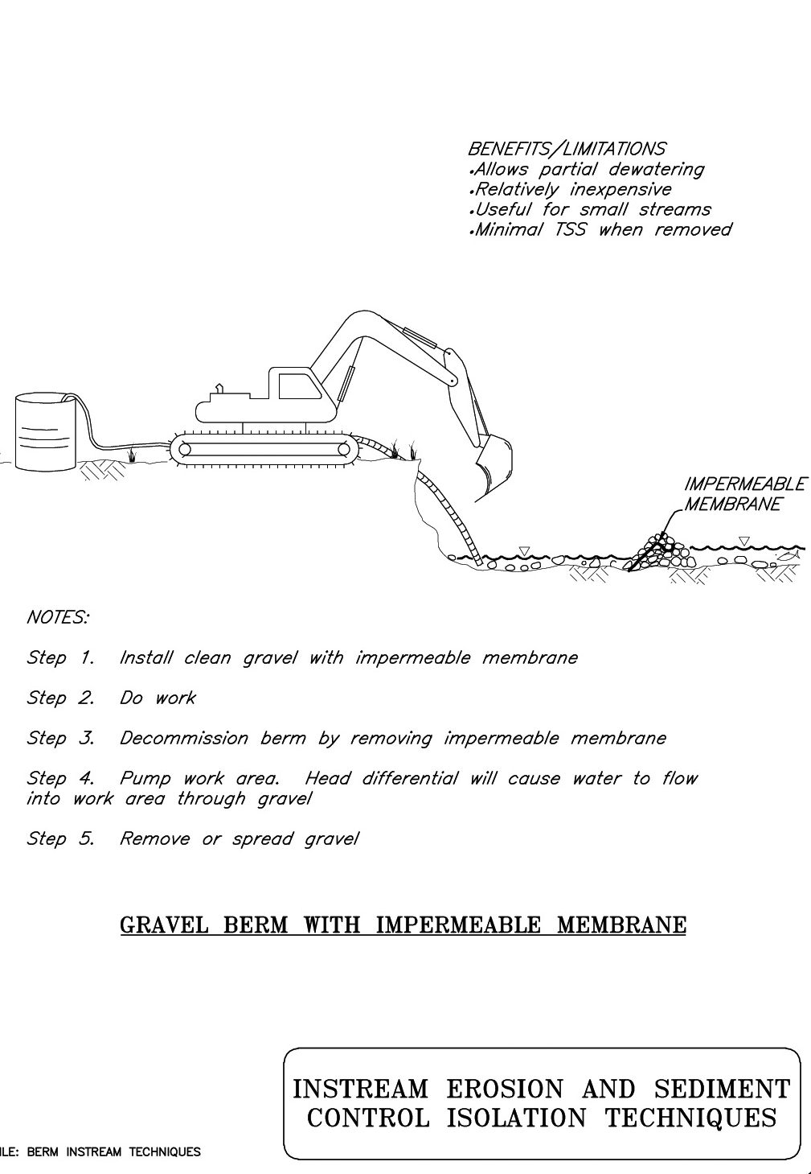

Figure 1B
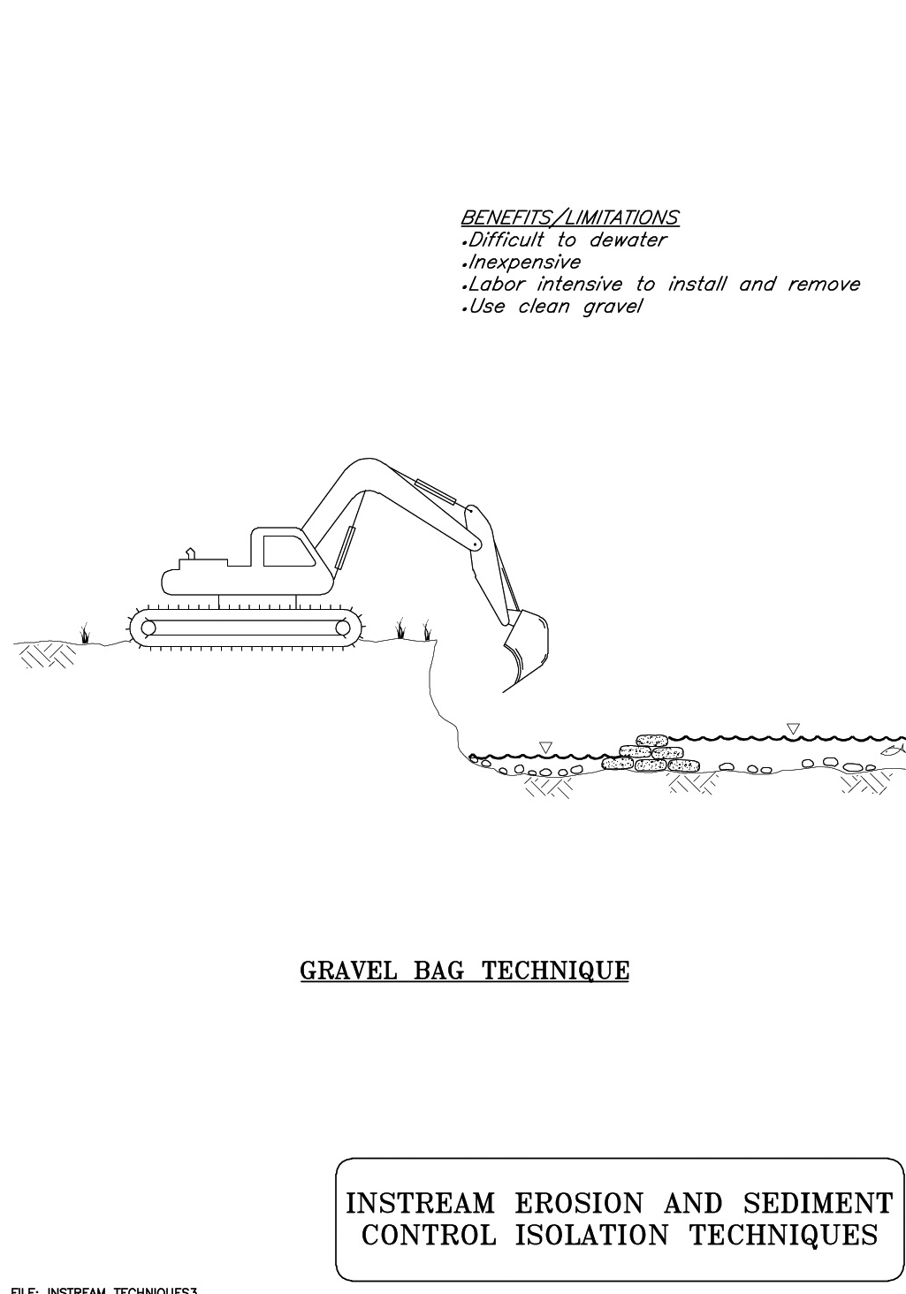

Figure 1C
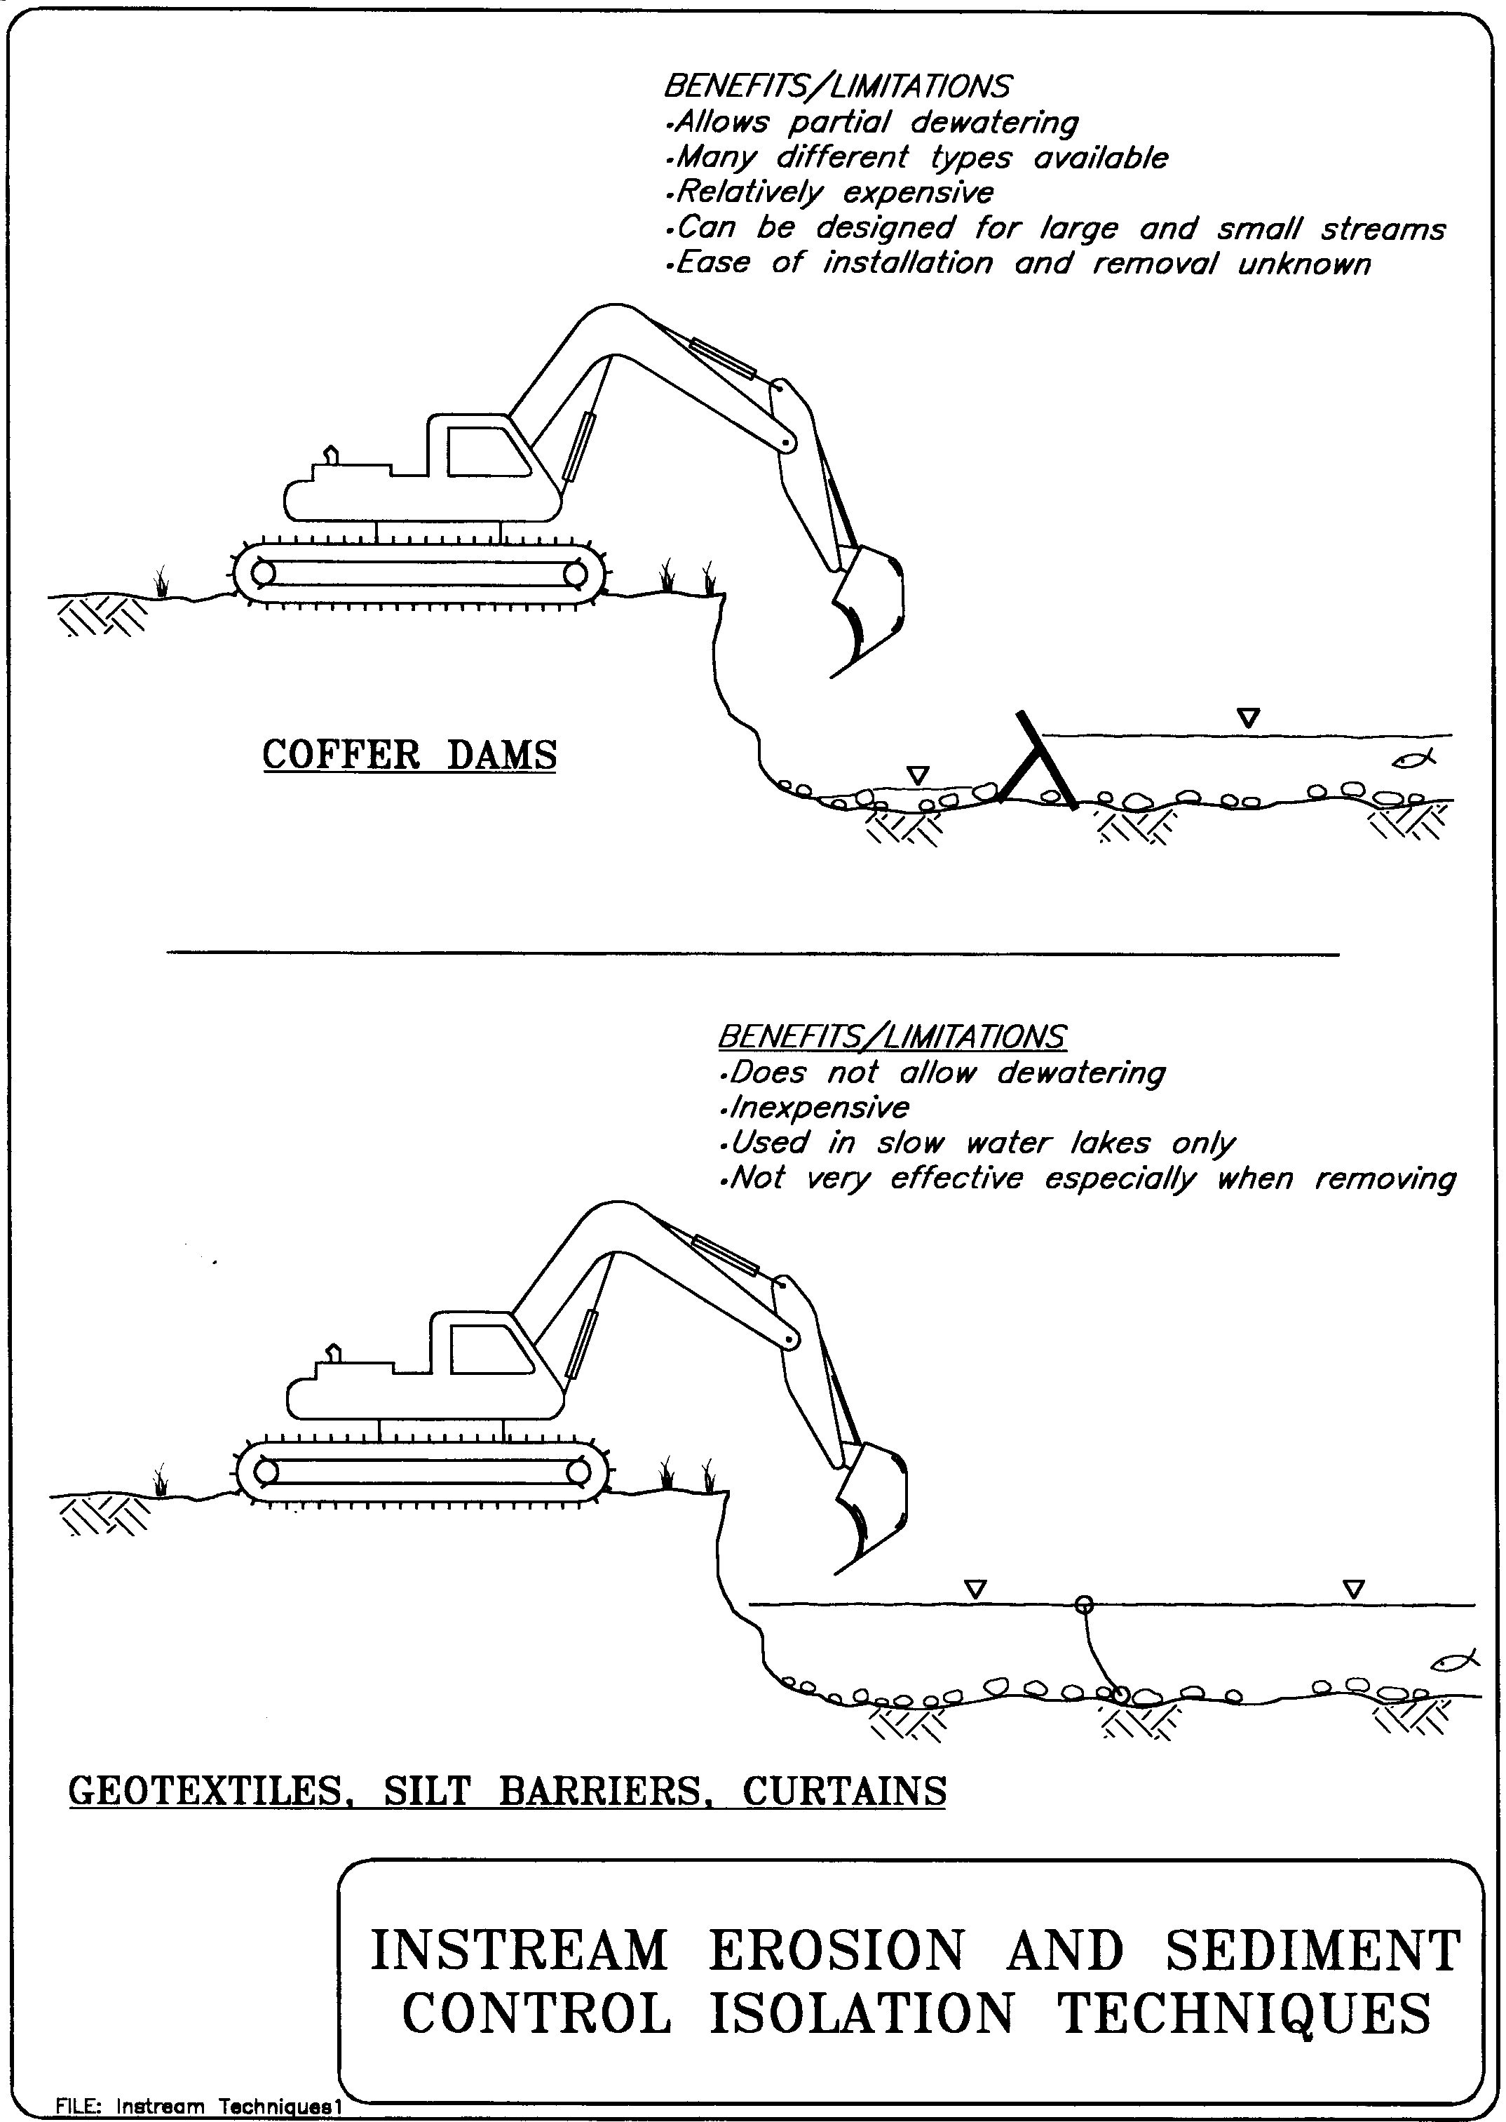

Figure 1D

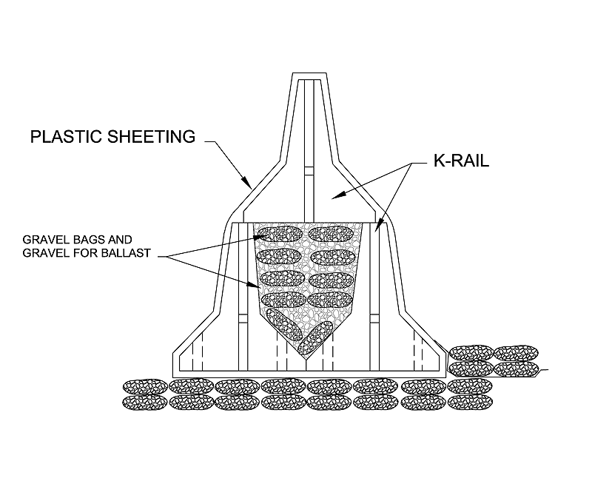

K-Rail Isolation
Figure 2

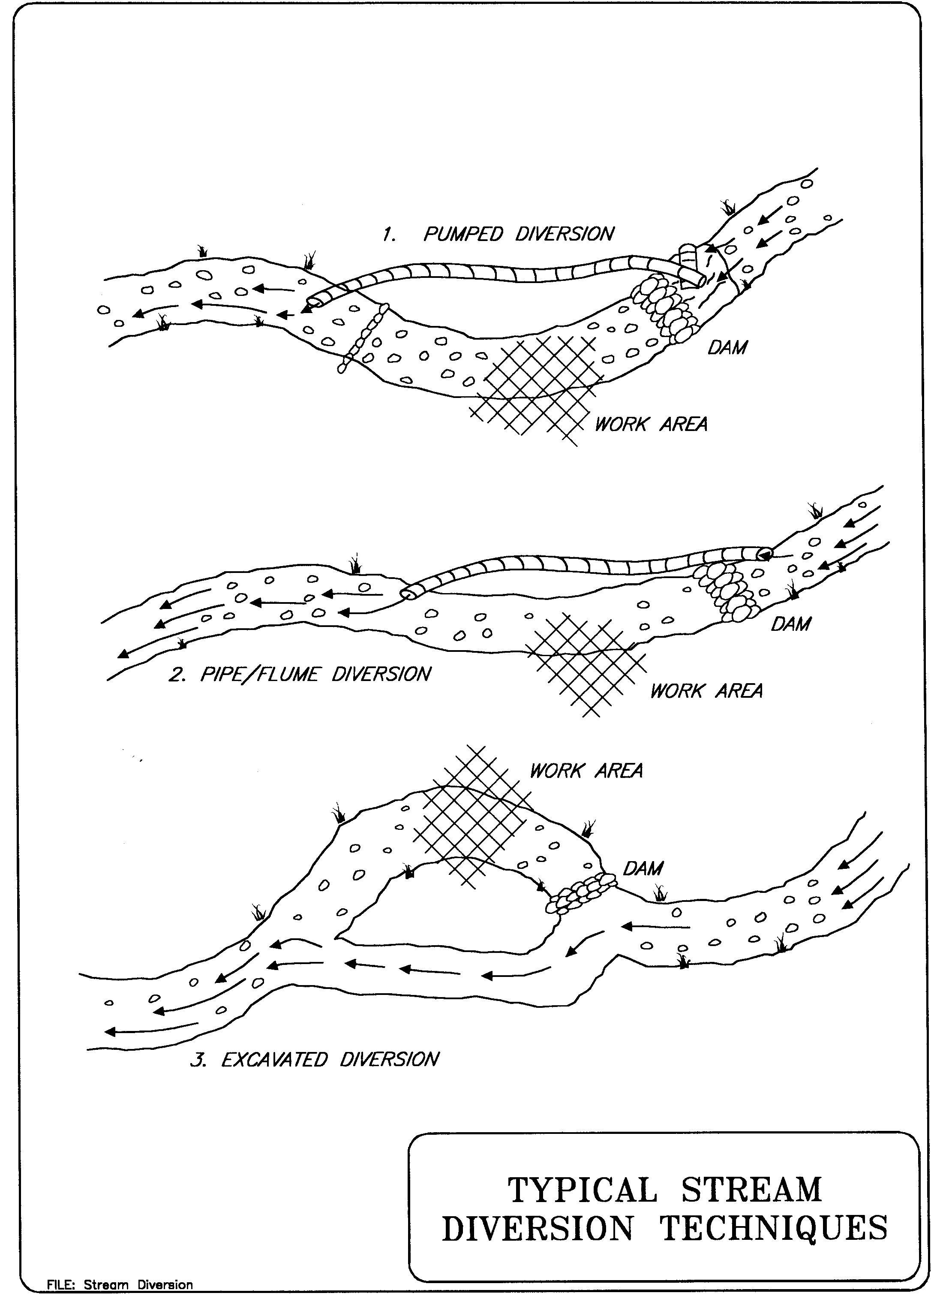

Figure 3

