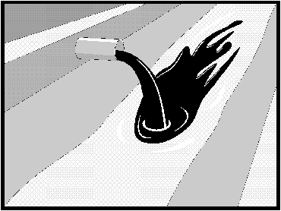    Definition and  ○  ○  ○  ○  ●  ○  Standard Symbol  Purpose | Procedures and practices designed for construction contractors to recognize illicit connections or illegally dumped or discharged materials on a construction site and report incidents to the Resident Engineer (RE).
Appropriate  Applications | - Illicit connection/illegal discharge detection and reporting is applicable anytime an illicit connection or discharge is discovered or illegally dumped material is found on the construction site.  - This best management practice (BMP) applies to all construction projects.
Limitations | - Unlabeled or non-identifiable material shall be assumed to be hazardous.  - Illicit connections and illegal discharges or dumping, for the purposes of this BMP, refer to discharges and dumping caused by parties other than the contractor.  - Procedures and practices presented in this BMP are general. Contractor shall use extreme caution, immediately notify the RE when illicit connections or illegal dumping or discharges are discovered, and take no further action unless directed by the RE.  - If pre-existing hazardous materials or wastes are known to exist onsite, the contractor's responsibility will be detailed in separate special provisions.
Standards and  Specifications | Planning  - Inspect site before beginning the job for evidence of illicit connections or illegal dumping or discharges.  - Inspect site regularly during project execution for evidence of illicit connections or illegal dumping or discharges.  - Observe site perimeter for evidence or potential of illicitly discharged or illegally dumped material, which may enter the job site.  Identification of illicit connections and illegal dumping or discharges.  - Solids - Look for debris, or rubbish piles. Solid waste dumping often occurs on roadways with light traffic loads or in areas not easily visible from the traveled way.  - Liquids – signs of illegal liquid dumping or discharge can include:  - Visible signs of staining or unusual colors to the pavement or surrounding adjacent soils.  - Pungent odors coming from the drainage systems.  - Discoloration or oily substances in the water or stains and residues detained within ditches, channels or drain boxes.  - Abnormal water flow during the dry weather season.  - Urban Areas - Evidence of illicit connections or illegal discharges is typically detected at storm drain outfall locations or at manholes. Signs of an illicit connection or illegal discharge can include:  - Abnormal water flow during the dry weather season.  - Unusual flows in subdrain systems used for dewatering.  - Pungent odors coming from the drainage systems.  - Discoloration or oily substances in the water or stains and residues detained within ditches, channels or drain boxes.  - Excessive sediment deposits, particularly adjacent to or near active off-site construction projects.  - Rural Areas - Illicit connections or illegal discharges involving irrigation drainage ditches are detected by visual inspections. Signs of an illicit discharge can include:  - Abnormal water flow during the dry weather season.  - Non-standard junction structures.  - Broken concrete or other disturbances at or near junction structures.  Reporting  - Notify the RE of any illicit connections and illegal dumping or discharge incidents at the time of discovery. The RE will notify the District Construction Storm Water Coordinator and the Construction Hazmat Coordinator for reporting.
Cleanup and  Removal | The contractor is not responsible for investigation and clean up of illicit or illegal dumping or discharges not generated by the contractor. Caltrans may direct contractor to clean up non-hazardous dumped or discharged material on the construction site.

