Definition and Purpose  ○  ○  ○  ○  ●  ○  Standard Symbol | Dewatering Operations are practices that manage the discharge of pollutants when non-storm water and accumulated precipitation (storm water) must be removed from a work location so that construction work may be accomplished.
Appropriate  Applications | - These practices are implemented for discharges of non-storm water and storm water (accumulated rain water) from construction sites. Non-storm water includes, but is not limited to, groundwater, dewatering of piles, water from cofferdams, water diversions, and water used during construction activities that must be removed from a work area.  - Practices identified in this section are also appropriate for implementation when managing the removal of accumulated precipitation (storm water) from depressed areas at a construction site.  - Storm water mixed with non-storm water should be managed as non-storm water.
Limitations | - Dewatering operations for non-storm water will require, and must comply with, applicable local permits, project-specific permits, and regulations.  - Site conditions will dictate design and use of dewatering operations.  - A dewatering plan shall be submitted as part of the SWPPP/WPCP detailing the location of dewatering activities, equipment, and discharge point.  - The controls discussed in this best management practice (BMP) address sediment only. If the presence of polluted water with hazardous substances is identified in the contract, the contractor shall implement dewatering pollution controls as required by the contract documents. If the quality of water to be removed by dewatering is not identified as polluted in the contract documents, but is later determined by observation or testing to be polluted, the contractor shall notify the Resident Engineer (RE) and comply with Standard Specifications Section 5-1.116, “Differing Site Conditions.”  - Avoid dewatering discharges where possible by using the water for dust control, by infiltration, etc.
Standards and  Specifications | - Dewatering shall be conducted in accordance with the Field Guide to Construction Site Dewatering, October 2001, CTSW-RT-01-010.  - Dewatering for accumulated precipitation (storm water) shall follow this BMP and use treatment measures specified herein.  - The RWQCB may require a separate NPDES permit prior to the dewatering discharge of non-storm water. These permits will have specific testing, monitoring, and discharge requirements and can take significant time to obtain.  - Except in RWQCB Regions 1 and 2, the discharge of accumulated precipitation (storm water) to a water body or storm drain is subject to the requirements of Caltrans NPDES permit. Sediment control and other appropriate BMPs (e.g., outlet protection/energy dissipation) must be employed when this water is discharged.  - RWQCB Regions 1 and 2 require notification and approval prior to any discharge of water from construction sites.  - In RWQCB Regions 3, 5, 7, and 9 non-storm water dewatering for discharges meeting certain conditions are allowed under an RWQCB general dewatering NPDES Permit. Notification and approval from the RWQCB is required prior to conducting these operations. This includes storm water that is mixed with groundwater or other non-storm water sources. Once the discharge is allowed, appropriate BMPs must be implemented to ensure that the discharge complies with all permit requirements. Conditions for potential discharge under an RWQCB general dewatering NPDES Permit include:  - Regions 3, 5, 7: Non-storm water discharges, free of pollutants other than sediment, <0.25 MGD, with a duration of 4 or fewer months.  - Region 9: Groundwater, free of pollutants other than sediment, <0.10 MGD, to surface waters other than San Diego Bay.  - The flow chart shown on Page 4 shall be utilized to guide dewatering operations.  - The RE will coordinate monitoring and permit compliance.  - Discharges must comply with regional and watershed-specific discharge requirements.  - Additional permits or permissions from other agencies may be required for dewatering cofferdams or diversions.  - Dewatering discharges must not cause erosion at the discharge point.  - Dewatering records shall be maintained for a period of 3 years.
Maintenance and  Inspection | - Inspect all BMPs implemented to comply with permit requirements frequently and repair or replace to ensure the BMPs function as designed.  - Conduct water quality monitoring pursuant to the “Storm Water Dewatering Operations BMP Discharge Monitoring Forms”.  - Accumulated sediment removed during the maintenance of a dewatering device may be incorporated in the project at locations designated by the RE or disposed of outside the right-of-way in conformance with the Standard Specifications.  - Accumulated sediment that is commingled with other pollutants must be disposed of in accordance with all applicable laws and regulations and as approved by the RE.

=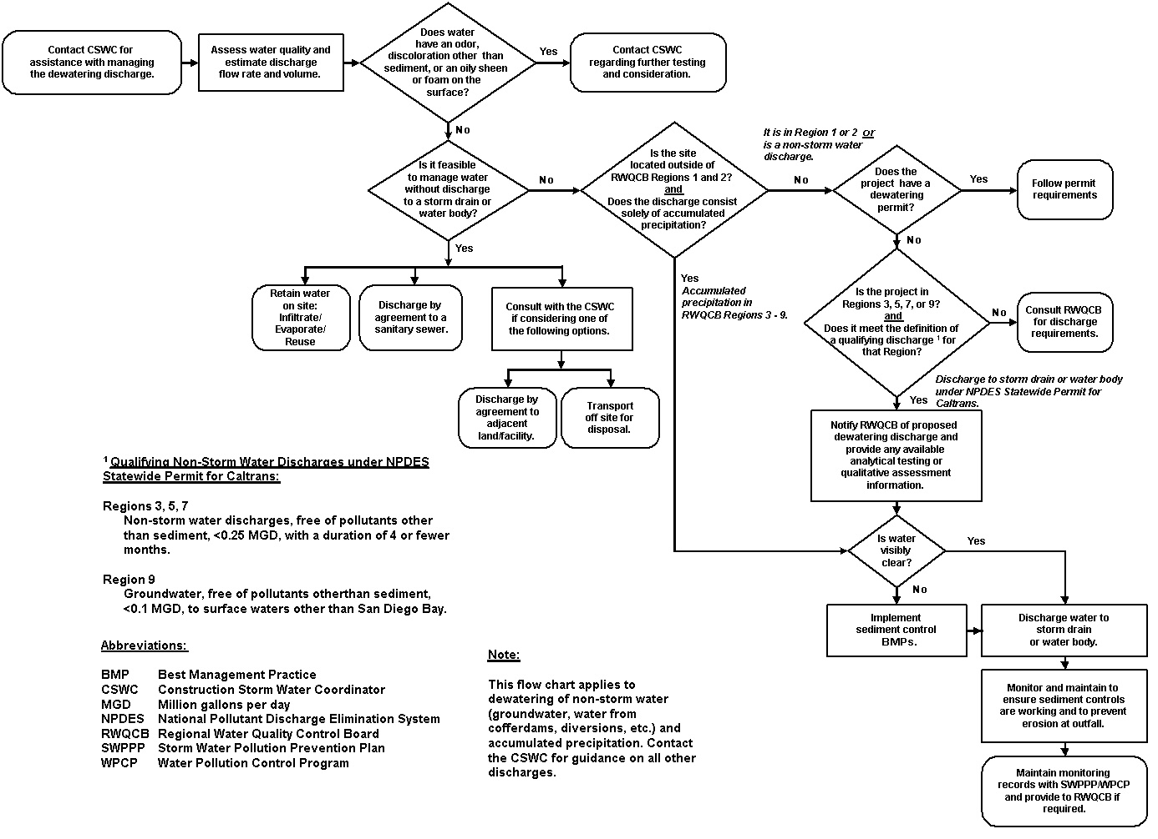
Sediment Treatment | A variety of methods can be used to treat water during dewatering operations from the construction site. Several devices are presented in this section that provide options to achieve sediment removal. The size of particles present in the sediment and Permit or receiving water limitations on sediment are key considerations for selecting sediment treatment option(s); in some cases, the use of multiple devices may be appropriate.
Category 1: Constructed Settling Technologies
The devices discussed in this category are to be used exclusively for dewatering operations only.

Sediment/Desilting Basin (SC-2)
Description:
A desilting basin is a temporary basin with a controlled release structure that is formed by excavation and/or construction of an embankment to detain sediment-laden runoff and allow sediment to settle out before discharging.
Appropriate Applications:
- Effective for the removal of trash, gravel, sand, and silt and some metals that settle out with the sediment.
Implementation:
- Excavation and construction of related facilities is required.
- Temporary desilting basins must be fenced if safety is a concern.
- Outlet protection is required to prevent erosion at the outfall location.
Maintenance:
- Maintenance is required for safety fencing, vegetation, embankment, inlet and outfall structures, as well as other features.
- Removal of sediment is required when the storage volume is reduced by one-third.

Sediment Trap (SC-3)
Description:
A sediment trap is a temporary basin formed by excavation and/or construction of an earthen embankment across a waterway or low drainage area to detain sediment-laden runoff and allow sediment to settle out before discharging.

Appropriate Applications:
- Effective for the removal of large and medium sized particles (sand and gravel) and some metals that settle out with the sediment.
Implementation:
- Excavation and construction of related facilities is required.
- Trap inlets shall be located to maximize the travel distance to the trap outlet.
- Use rock or vegetation to protect the trap outlets against erosion.
Maintenance:
- Maintenance is required for vegetation, embankment, inlet and outfall structures, as well as other features.
- Removal of sediment is required when the storage volume is reduced by one-third.
Category 2: Mobile Settling Technologies
The devices discussed in this category are typical of tanks that can be used for sediment treatment of dewatering operations. A variety of vendors are available who supply these tanks.
Weir Tank
Description:
A weir tank separates water and waste by using weirs. The configuration of the weirs (over and under weirs) maximizes the residence time in the tank and determines the waste to be removed from the water, such as oil, grease, and sediments.
Appropriate Applications:
- The tank removes trash, some settleable solids (gravel, sand, and silt), some visible oil and grease, and some metals (removed with sediment). To achieve high levels of flow, multiple tanks can be used in parallel. If additional treatment is desired, the tanks can be placed in series or as pre-treatment for other methods.
Implementation:
- Tanks are delivered to the site by the vendor, who can provide assistance with set-up and operation.
- Tank size will depend on flow volume, constituents of concern, and residency period required. Vendors shall be consulted to appropriately size tank.
Maintenance:
- Periodic cleaning is required based on visual inspection or reduced flow.
- Oil and grease disposal must be by licensed waste disposal company.
Weir Tanks | Schematic Diagrams:

Dewatering Tank
Description:
A dewatering tank removes debris and sediment. Flow enters the tank through the top, passes through a fabric filter, and is discharged through the bottom of the tank. The filter separates the solids from the liquids.
Appropriate Applications:
- The tank removes trash, gravel, sand, and silt, some visible oil and grease, and some metals (removed with sediment). To achieve high levels of flow, multiple tanks can be used in parallel. If additional treatment is desired, the tanks can be placed in series or as pre-treatment for other methods.
Implementation:
- Tanks are delivered to the site by the vendor, who can provide assistance with set-up and operation.
- Tank size will depend on flow volume, constituents of concern, and residency period required. Vendors shall be consulted to appropriately size tank.
Maintenance:
- Periodic cleaning is required based on visual inspection or reduced flow.
- Oil and grease disposal must be by licensed waste disposal company.
Dewatering Tanks | Schematic Diagrams:

Category 3: Basic Filtration Technologies

Gravity Bag Filter
Description:
A gravity bag filter, also referred to as a dewatering bag, is a square or rectangular bag made of non-woven geotextile fabric that collects sand, silt, and fines.
Appropriate Applications:
- Effective for the removal of sediments (gravel, sand, and silt). Some metals are removed with the sediment.
Implementation:
- Water is pumped into one side of the bag and seeps through the bottom and sides of the bag.
- A secondary barrier, such as a rock filter bed or straw/hay bale barrier, is placed beneath and beyond the edges of the bag to capture sediments that escape the bag.
Maintenance:
- Inspection of the flow conditions, bag condition, bag capacity, and the secondary barrier is required.
- Replace the bag when it no longer filters sediment or passes water at a reasonable rate.
- The bag is disposed off-site, or on-site as directed by the RE.
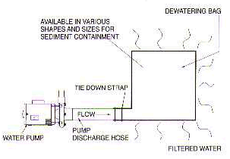  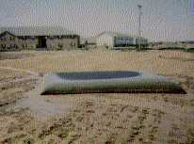  Gravity Bag Filter | Schematic Diagrams:
Category 4: Advanced Filtration Technologies

Sand Media Particulate Filter
Description:
Water is treated by passing it through canisters filled with sand media. Generally, sand filters provide a final level of treatment. They are often used as a secondary or higher level of treatment after a significant amount of sediment and other pollutants have been removed.
Appropriate Applications:
- Effective for the removal of trash, gravel, sand, and silt and some metals, as well as the reduction of biochemical oxygen demand (BOD) and turbidity.
- Sand filters can be used for standalone treatment or in conjunction with bag and cartridge filtration if further treatment is required.
- Sand filters can also be used to provide additional treatment to water treated via settling or basic filtration.
Implementation:
- The filters require delivery to the site and initial set up. The vendor can provide assistance with installation and operation.
Maintenance:
- The filters require monthly service to monitor and maintain the sand media.
Schematic Diagrams:

Sand Media Particulate Filters

Pressurized Bag Filter
Description:
A pressurized bag filter is a unit composed of single filter bags made from polyester felt material. The water filters through the unit and is discharged through a header, allowing for the discharge of flow in series to an additional treatment unit. Vendors provide pressurized bag filters in a variety of configurations. Some units include a combination of bag filters and cartridge filters for enhanced contaminant removal.
Appropriate Applications:
- Effective for the removal of sediment (sand and silt) and some metals, as well as the reduction of BOD, turbidity, and hydrocarbons. Oil absorbent bags are available for hydrocarbon removal.
- Filters can be used to provide secondary treatment to water treated via settling or basic filtration.
Implementation:
- The filters require delivery to the site and initial set up. The vendor can provide assistance with installation and operation.
Maintenance:
- The filter bags require replacement when the pressure differential exceeds the manufacturer’s recommendation.

Pressurized Bag Filter | Schematic Diagrams:

Cartridge Filter
Description:
Cartridge filters provide a high degree of pollutant removal by utilizing a number of individual cartridges as part of a larger filtering unit. They are often used as a secondary or higher (polishing) level of treatment after a significant amount of sediment and other pollutants are removed. Units come with various cartridge configurations (for use in series with pressurized bag filters) or with a larger single cartridge filtration unit (with multiple filters within).
Appropriate Applications:
- Effective for the removal of sediment (sand, silt, and some clays) and metals, as well as the reduction of BOD, turbidity, and hydrocarbons. Hydrocarbons can effectively be removed with special resin cartridges.
- Filters can be used to provide secondary treatment to water treated via settling or basic filtration.
Implementation:
- The filters require delivery to the site and initial set up. The vendor can provide assistance.
Maintenance:
- The cartridges require replacement when the pressure differential exceeds the manufacturer’s recommendation.
Schematic Designs:

Cartridge Filter

