Definition and  ○  ●  ○  ○  ○  ○  Standard Symbol  Purpose | A sediment/desilting basin is a temporary basin formed by excavating and/or constructing an embankment so that sediment-laden runoff is temporarily detained under quiescent conditions, allowing sediment to settle out before the runoff is discharged (refer to Figures 1 and 2).
Appropriate  Applications | Sediment basins shall be designed in accordance with Section A of the State of California NPDES General Permit for Storm Water Discharges Associated with Construction Activities (General Permit). If there is insufficient area to construct a sediment basin in accordance with the General Permit requirements, then the alternate desilting design standards specified herein may be used. This BMP may be implemented on a project-by-project basis with other BMPs when determined necessary and feasible by the RE.  Sediment/Desilting Basins shall be considered for use:  - On construction projects with disturbed areas during the rainy season.  - Where sediment-laden water may enter the drainage system or watercourses.  - At outlets of disturbed soil areas with areas between 2 ha and 4 ha (5 ac and 10 ac).
Limitations | - Alternative BMPs must be thoroughly investigated for erosion control before selecting temporary desilting basins.  - Requires large surface areas to permit settling of sediment.  - Not appropriate for drainage areas greater than 30 ha (75 ac).  - Not to be located in live streams  - For safety reasons, basins shall have protective fencing.  - Size may be limited by availability of right-of-way.
Standards and  Specifications | - Limit the contributing area to the sediment/desilting basin to only the runoff from the disturbed soil areas. Use temporary concentrated flow conveyance controls to divert runoff from undisturbed areas away from the sediment/desilting basin.  Sediment Basin  - Sediment basins shall, at a minimum, be designed as follows:  - Option 1: Pursuant to local ordinance for sediment basin design and maintenance, provided that the design efficiency is as protective or more protective of water quality than Option 3.  OR  - Option 2: Sediment basin(s), as measured from the bottom of the basin to the principal outlet, shall have at least a capacity equivalent to 102 cubic meters (3,600 cubic feet) of storage per 0.4 hectare (1 acre) draining into the sediment basin. The length of the basin shall be more than twice the width of the basin. The length is determined by measuring the distance between the inlet and the outlet; and the depth must not be less than 0.9 m (3 ft) nor greater than 1.5 m (5 ft) for safety reasons and for maximum efficiency.  OR  - Option 3: Sediment basin(s) shall be designed using the standard equation:  As=1.2Q/Vs (Eq. 1)  Where:  As = Minimum surface area for trapping soil particles of a certain size  Vs = Settling velocity of the design particle size chosen  Q = C I A  Where:  Q = Discharge rate measured in cubic feet per second  C = Runoff coefficient  I = Precipitation intensity for the 10-year, 6-hour rain event  A = Area draining into the sediment basin in acres  The design particle size shall be the smallest soil grain size determined by wet sieve analysis, or the fine silt sized (0.01mm) particle, and the Vs used shall be 100 percent of the calculated settling velocity.  The length is determined by measuring the distance between the inlet and the outlet; the length shall be more than twice the dimension as the width; the depth shall not be less than 0.9 m (3 ft) nor greater than 1.5 m (5 ft) for safety reasons and for maximum efficiency [0.6 m (2 ft) of sediment storage, 0.6 m (2 ft) of capacity). The basin(s) shall be located on the site where it can be maintained on a year-round basis and shall be maintained on a schedule to retain the 0.6 m (2 ft) of capacity.  OR  - Option 4: The use of an equivalent surface area design or equation, provided that the design efficiency is as protective or more protective of water quality than Option 3.  Desilting Basin  - Desilting basins shall be designed to have a capacity equivalent to 100 cubic meters of storage (as measured from the top of the basin to the principal outlet) per hectare of contributory area. This design is less than the required to capture the 0.01 mm particle size but larger than that required to capture particles 0.02 mm or larger.  - The length of the basin shall be more than twice the width of the basin; the length shall be determined by measuring the distance between the inlet and the outlet.  - The depth must be no less than one (1) meter nor greater than 1.5 m.  - Basins with an impounding levee greater than 1.5 m (5 ft) tall, measured from the lowest point to the impounding area to the highest point of the levee, and basins capable of impounding more than 1000 cubic meters (35,300 cubic feet), shall be designed by a professional Civil Engineer registered with the state of California. The design must be submitted to the Resident Engineer (RE) for approval at least 7 days prior to the basin construction. The design shall include maintenance requirements, including sediment and vegetation removal, to ensure continuous function of the basin outlet and bypass structures.  General Requirements  - Design and locate sediment/desilting basins so that they can be maintained. Construct desilting basins prior to the rainy season and construction activities.  - Sediment/desilting basins, regardless of size and storage volume, shall include features to accommodate overflow or bypass flows that exceed the design storm event. The calculated basin volume and proposed location shall be submitted to the RE for approval at least 3 days prior to the basin construction.  - Construct an emergency spillway to accommodate flows not carried by the principal spillway. Spillway shall consist of an open channel (earthen or vegetated) over undisturbed material (not fill) or constructed of a non-erodible riprap.  - Spillway control section, which is a level portion of the spillway channel at the highest elevation in the channel, shall be a minimum of 6 m (20 ft) in length.  - A forebay, constructed upstream of the basin may be provided to remove debris and larger particles.  - Basin inlets shall be located to maximize travel distance to the basin outlet.  - Rock or vegetation shall be used to protect the basin inlet and slopes against erosion.  - The outflow from the basins shall be provided with outlet protection to prevent erosion and scouring of the embankment and channel. See BMP SS-10, “Outlet Protection/Velocity Dissipation Devices.”  - Basin shall be located: (1) by excavating a suitable area or where a low embankment can be constructed across a swale, (2) where post-construction (permanent) detention basins will be constructed, (3) where failure would not cause loss of life or property damage, (4) where the basins can be maintained on a year-round basins to provide access for maintenance, including sediment removal and sediment stockpiling in a protected area, and to maintain the basin to provide the required capacity.  - Areas under embankments, structural works, and sediment/desilting basin must be cleared, stripped of vegetation in accordance with Standard Specifications Section 16 – “Clearing and Grubbing.”  - Earthwork shall be in accordance with Standard Specifications Section 19 – “Earthwork”. Contractor is specifically directed to Standard Specifications Sections 19-5, “Compaction,” and 19-6, “Embankment Construction.”  - Structure shall be placed on a firm, smooth foundation with the base securely anchored with concrete or other means to prevent floatation.  - Discharge from the basin shall be accomplished through a water quality outlet. An example is shown in Figure 3. The Principal outlet shall consist of a corrugated metal, high density polyethylene (HDPE), or reinforced concrete riser pipe with dewatering holes and an anti-vortex device and trash rack attached to the top of the riser, to prevent floating debris from flowing out of the basin or obstructing the system. This principal structure shall be designed to accommodate the inflow design storm.  - A rock pile or rock-filled gabions can serve as alternatives to the debris screen, although the designer should be aware of the potential for extra maintenance involved should the pore spaces in the rock pile clog.  - Proper hydraulic design of the outlet is critical to achieving the desired performance of the basin. The water quality outlet should be designed to drain the basin within 24 to 72 hours (also referred to as “drawdown time”). (The 24-hour limit is specified to provide adequate settling time; the 72-hour limit is specified to mitigate vector control concerns.)  - The two most common outlet problems that occur are: (1) the capacity of the outlet is too great resulting in only partial filling of the basin and drawdown time less than designed for; and (2) the outlet clogs because it is not adequately protected against trash and debris. To avoid these problems, the following outlet types are recommended for use: (1) a single orifice outlet with or without the protection of a riser pipe, and (2) perforated riser. Design guidance for single orifice and perforated riser outlets are as follows:  Flow Control Using a Single Orifice At The Bottom Of The Basin (Figure 1): The outlet control orifice should be sized using the following equation:  $a=\frac{2A(H−\text{Ho})^{0\text{.}5}}{\text{3600}\text{CT}(2g)^{0\text{.}5}}=\frac{(7x{\text{10}}^{−5})A(H−\text{Ho})^{0\text{.}5}}{\text{CT}}$ (Eq. 2)  where:  a = area of orifice (ft²) (1 ft² =0.0929m²)  A = surface area of the basin at mid elevation (ft²)  C = orifice coefficient  T = drawdown time of full basin (hrs)  G = gravity (32.2 ft/s²)  H = elevation when the basin is full (ft)  Ho = final elevation when basin is empty (ft)  With a drawdown time of 40 hours, the equation becomes:  $a=\frac{(1\text{.}\text{75}x{\text{10}}^{−6})A(H−\text{Ho})^{0\text{.}5}}{C}$ (Eq. 3)  Flow Control Using Multiple Orifices (see Figure2):  $a_{t}=\frac{2A(h_{\text{max}})}{\text{CT}(2g[h_{\text{max}}−h_{\text{centroid}\text{of}\text{orifices}}])^{0\text{.}5}}$ (Eq. 4)  With terms as described above except:  a_{t} = total area of orifices  h_{max} = maximum height from lowest orifice to the maximum water surface (ft)  h_{centroid of orifices} = height from the lowest orifice to the centroid of the orifice configuration (ft)  Allocate the orifices evenly on two rows; separate the holes by 3x hole diameter vertically, and by 120 degrees horizontally (refer to Figure 3).  Because basins are not maintained for infiltration, water loss by infiltration should be disregarded when designing the hydraulic capacity of the outlet structure.  Care must be taken in the selection of "C"; 0.60 is most often recommended and used. However, based on actual tests, GKY (1989), "Outlet Hydraulics of Extended Detention Facilities for Northern Virginia Planning District Commission", recommends the following:  C = 0.66 for thin materials; where the thickness is equal to or less than the orifice diameter, or  C = 0.80 when the material is thicker than the orifice diameter  - The Contractor shall verify that the outlet is properly designed to handle the design and peak flows.  - Attach riser pipe (watertight connection) to a horizontal pipe (barrel), which extends through the embankment to toe of fill. Provide anti-seep collars on the barrel.  - Cleanout level shall be clearly marked on the riser pipe  - Avoid dewatering of groundwater to the sediment/desilting basin during the rainy season. Insignificant quantities of accumulated precipitation may be dewatered to the sediment/desilting basin unless precipitation is forecasted within 24 hours. Refer to NS-2 “Dewatering Operations.”  - Chain link fencing shall be provided around each sediment/desilting basin to prevent unauthorized entry to the basin or if safety is a concern. Fencing shall be in accordance with Standard Specifications Section 80 – “Fencing.”
Maintenance and  Inspection | - Inspect sediment/desilting basins before and after rainfall events and weekly during the rest of the rainy season. During extended rainfall events, inspect at least every 24 hours.  - Examine basin banks for seepage and structural soundness.  - Check inlet and outlet structures and spillway for any damage or obstructions. Repair damage and remove obstructions as needed, or as directed by the RE.  - Remove standing water from the basin within 72 hours after accumulation.  - Check inlet and outlet area for erosion and stabilize if required, or if directed by the RE.  - Remove accumulated sediment when its volume reaches one-third the volume of the sediment storage. Properly dispose of sediment and debris removed from the basin.  - Check fencing for damage and repair as needed or as directed by the RE.

Sediment storage depth
permanent pool
FIGURE 1: SINGLE ORIFICE DESIGN
NOT TO SCALE

Anti floatation block

FIGURE 2: MULTIPLE ORIFICE DESIGN
NOT TO SCALE

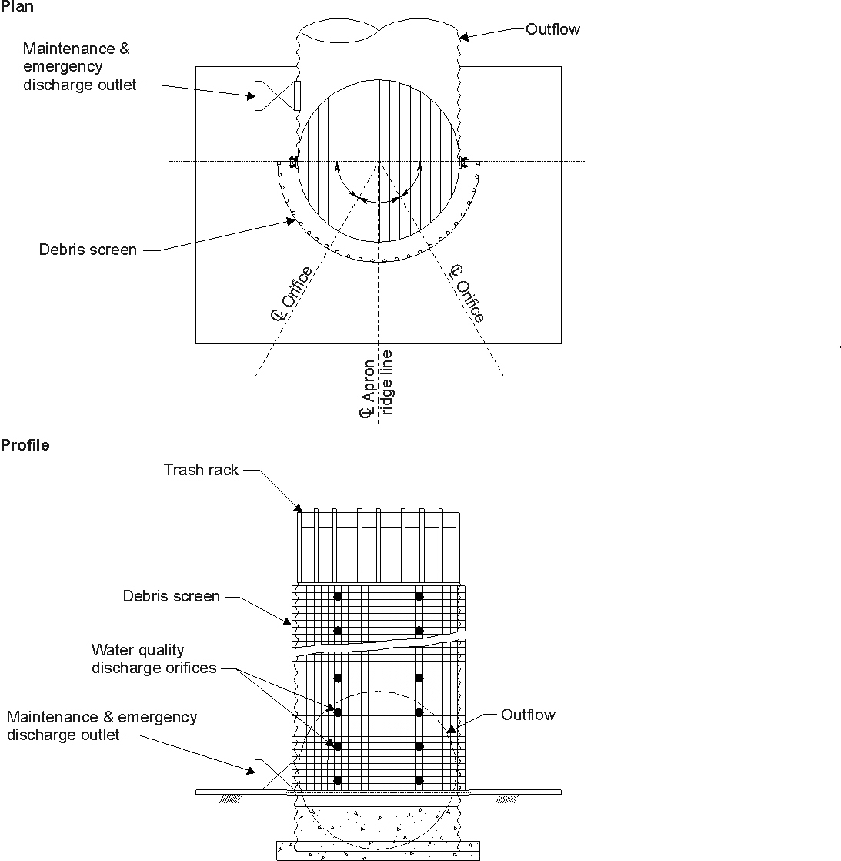

FIGURE 3: MULTIPLE ORIFICE OUTLET RISER

NOT TO SCALE

