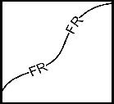  Definition and  ●  ●  ○  ○  ○  ○  Standard Symbol  Purpose | A fiber roll consists of wood excelsior, rice or wheat straw, or coconut fibers that is rolled or bound into a tight tubular roll and placed on the toe and face of slopes to intercept runoff, reduce its flow velocity, release the runoff as sheet flow and provide removal of sediment from the runoff. Fiber rolls may also be used for inlet protection and as check dams under certain situations.
Appropriate  Applications | - This BMP may be implemented on a project-by-project basis with other BMPs when determined necessary and feasible by the RE.  - Along the toe, top, face, and at grade breaks of exposed and erodible slopes to shorten slope length and spread runoff as sheet flow.  - Below the toe of exposed and erodible slopes.  - Fiber rolls may be used as check dams in unlined ditches if approved by the Resident Engineer (RE) or the District Construction Storm Water Coordinator (refer to SC-4 “Check Dams”).  - Fiber rolls may be used for drain inlet protection if approved by the RE or the District Construction Storm Water Coordinator (refer to SC-10 “Storm Drain Inlet Protection”).  - Down-slope of exposed soil areas.  - Around temporary stockpiles.  - Along the perimeter of a project.
Limitations | - Runoff and erosion may occur if fiber roll is not adequately trenched in.  - Fiber rolls at the toe of slopes greater than 1:5 may require the use of 500 mm (20” diameter) or installations achieving the same protection (i.e., stacked smaller diameter fiber rolls, etc.).  - Fiber rolls may be used for drainage inlet protection if they can be properly anchored.  - Difficult to move once saturated.  - Fiber rolls could be transported by high flows if not properly staked and trenched in.  - Fiber rolls have limited sediment capture zone.  - Do not use fiber rolls on slopes subject to creep, slumping, or landslide.
Standards and  Specifications | Fiber Roll Materials  - Fiber rolls shall be either:  - Prefabricated rolls.  - Rolled tubes of erosion control blanket.  Assembly of Field Rolled Fiber Roll  - Roll length of erosion control blanket into a tube of minimum 200 mm (8 in) diameter.  - Bind roll at each end and every 1.2 m (4 ft) along length of roll with jute-type twine.  Installation  - Slope inclination of 1:4 or flatter: fiber rolls shall be placed on slopes 6.0 m apart.  - Slope inclination of 1:4 to 1:2: fiber rolls shall be placed on slopes 4.5 m apart.  - Slope inclination 1:2 or greater: fiber rolls shall be placed on slopes 3.0 m apart.  - Stake fiber rolls into a 50 to 100 mm (2 to 4 in) trench.  - Drive stakes at the end of each fiber roll and spaced 600 mm (2 ft) apart if Type 2 installation is used (refer to Page 4). Otherwise, space stakes 1.2 m (4 ft) maximum on center if installed as shown on Pages 5 and 6.  - Use wood stakes with a nominal classification of 19 by 19 mm (3/4 by 3/4 in), and minimum length of 600 mm (24 in).  - If more than one fiber roll is placed in a row, the rolls shall be overlapped; not abutted.  Removal  - Fiber rolls are typically left in place.  - If fiber rolls are removed, collect and dispose of sediment accumulation, and fill and compact holes, trenches, depressions or any other ground disturbance to blend with adjacent ground.
Maintenance and  Inspection | - Repair or replace split, torn, unraveling, or slumping fiber rolls.  - Inspect fiber rolls when rain is forecast. Perform maintenance as needed or as required by the RE.  - Inspect fiber rolls following rainfall events and a least daily during prolonged rainfall. Perform maintenance as needed or as required by the RE.  - Maintain fiber rolls to provide an adequate sediment holding capacity. Sediment shall be removed when the sediment accumulation reaches three quarters (3/4) of the barrier height. Removed sediment shall be incorporated in the project at locations designated by the RE or disposed of outside the highway right-of-way in conformance with the Standard Specifications.

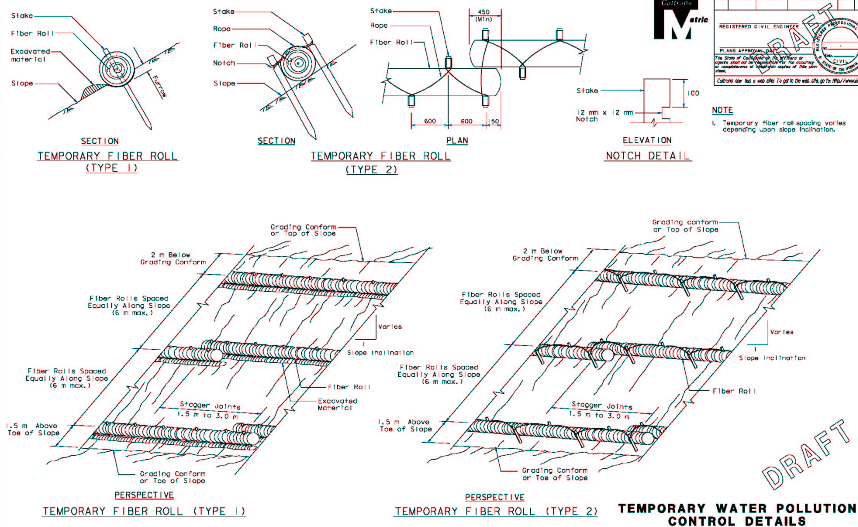
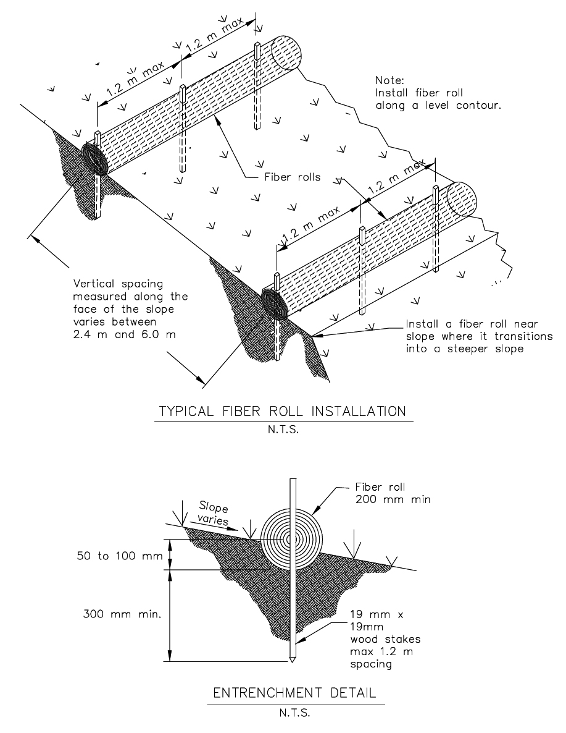
Vertical spacing along face of the slope varies between 3m and 6 m

OPTIONAL ENTRENCHMENT DETAIL
N.T.S.

