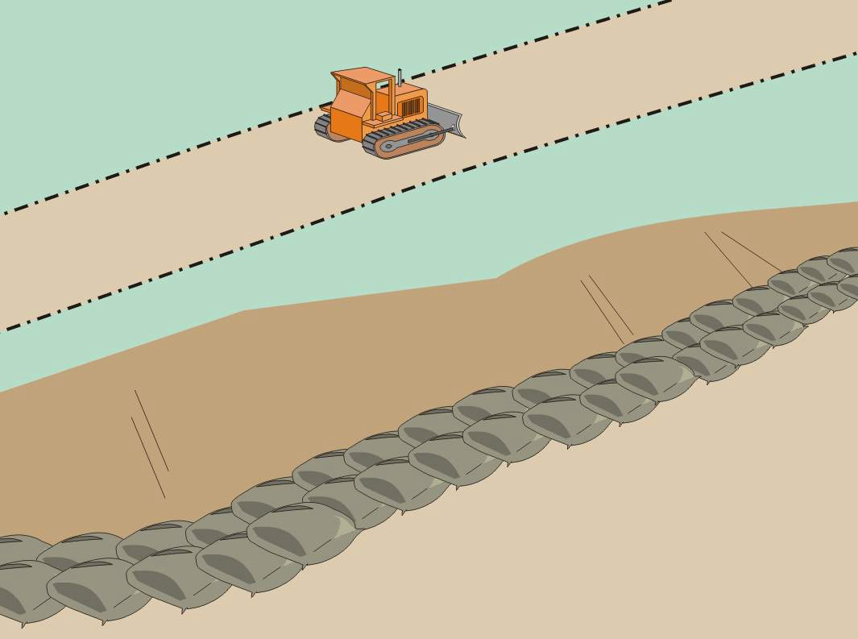  Definition and  ○  ●  ○  ○  ○  ○  Standard Symbol  Purpose | A gravel bag berm consists of a single row of gravel bags that are installed end to end to form a barrier across a slope to intercept runoff, reduce its flow velocity, release the runoff as sheet flow and provide some sediment removal. Gravel bags can be used where flows are moderately concentrated, such as ditches, swales, and storm drain inlets (see BMP SC-10, Storm Drain Inlet Protection) to divert and/or detain flows.
Appropriate  Applications | - BMP may be implemented on a project-by-project basis with other BMPs when determined necessary and feasible by the RE.  - Along streams and channels.  - Below the toe of exposed and erodible slopes.  - Down slope of exposed soil areas.  - Around stockpiles.  - Across channels to serve as a barrier for utility trenches or provide a temporary channel crossing for construction equipment, to reduce stream impacts.  - Parallel to a roadway to keep sediment off paved areas.  - At the top of slopes to divert roadway runoff away from disturbed slopes.  - Along the perimeter of a site.  - To divert or direct flow or create a temporary sediment basin.  - During construction activities in stream beds when the contributing drainage area is less than 2 ha (5 ac).  - When extended construction period limits the use of either silt fences or straw bale barriers.  - When site conditions or construction sequencing require adjustments or relocation of the barrier to meet changing field conditions and needs during construction.  - At grade breaks of exposed and erodible slopes to shorten slope length and spread runoff as sheet flow.
Limitations | - Degraded gravel bags may rupture when removed, spilling contents.  - Installation can be labor intensive.  - Limited durability for long term projects.  - When used to detain concentrated flows, maintenance requirements increase.
Standards and  Specifications | Materials  - Bag Material: Bags shall be woven polypropylene, polyethylene or polyamide fabric, minimum unit weight 135 g/m2 (four ounces per square yard), mullen burst strength exceeding 2,070 kPa (300 psi) in conformance with the requirements in ASTM designation D3786, and ultraviolet stability exceeding 70% in conformance with the requirements in ASTM designation D4355.  - Bag Size: Each gravel-filled bag shall have a length of 450 mm (18 in), width of 300 mm (12 in), thickness of 75 mm (3 in), and mass of approximately 15 kg (33 lb). Bag dimensions are nominal, and may vary based on locally available materials. Alternative bag sizes shall be submitted to the RE for approval prior to deployment.  - Fill Material: Gravel shall be between 10 mm and 20 mm (0.4 and 0.8 inch) in diameter, and shall be clean and free from clay balls, organic matter, and other deleterious materials. The opening of gravel-filled bags shall be between 13 kg and 22 kg (28 and 48 lb) in mass. Fill material is subject to approval by the RE.  Installation  - When used as a linear control for sediment removal:  - Install along a level contour.  - Turn ends of gravel bag row up slope to prevent flow around the ends.  - Generally, gravel bag barriers shall be used in conjunction with temporary soil stabilization controls up slope to provide effective erosion and sediment control.  - When used for concentrated flows:  - Stack gravel bags to required height using a pyramid approach.  - Upper rows of gravel bags shall overlap joints in lower rows.  - Construct gravel bag barriers with a set-back of at least 1m from the toe of a slope. Where it is determined to be not practicable due to specific site conditions, the gravel bag barrier may be constructed at the toe of the slope, but shall be constructed as far from the toe of the slope as practicable.  - Requires Certificate of Compliance per Standard Specifications 6-1.07.
Maintenance and  Inspection | - Inspect gravel bag berms before and after each rainfall event, and weekly throughout the rainy season.  - Reshape or replace gravel bags as needed, or as directed by the RE.  - Repair washouts or other damages as needed, or as directed by the RE.  - Inspect gravel bag berms for sediment accumulations and remove sediments when accumulation reaches one-third of the berm height. Removed sediment shall be incorporated in the project at locations designated by the RE or disposed of outside the highway right-of-way in conformance with the Standard Specifications.  - Remove gravel bag berms when no longer needed. Remove sediment accumulations and clean, re-grade, and stabilize the area.

