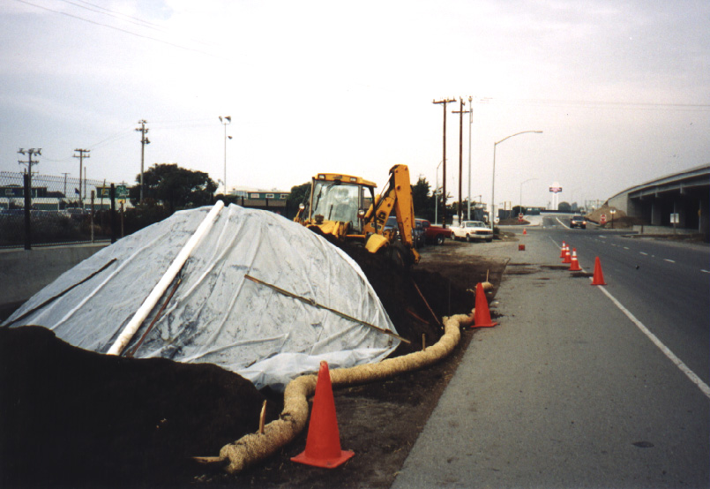  Definition and  ●  ●  ○  ○  ○  ●  Standard Symbol  Purpose | Stockpile management procedures and practices are designed to reduce or eliminate air and storm water pollution from stockpiles of soil, and paving materials such as portland cement concrete (PCC) rubble, asphalt concrete (AC), asphalt concrete rubble, aggregate base, aggregate subbase or pre-mixed aggregate, asphalt binder (so called “cold mix” asphalt) and pressure treated wood.
Appropriate  Applications | Implemented in all projects that stockpile soil and other materials.
Limitations | - None identified
Standards and  Specifications | - Protection of stockpiles is a year-round requirement.  - Locate stockpiles a minimum of 15 m (50 ft)away from concentrated flows of storm water, drainage courses, and inlets.  - Implement wind erosion control practices as appropriate on all stockpiled material. For specific information see BMP WE-1, “Wind Erosion Control.”  - Stockpiles of contaminated soil shall be managed in accordance with BMP WM-7, “Contaminated Soil Management.”  - Bagged materials should be placed on pallets and under cover.  Protection of Non-Active Stockpiles  Non-active stockpiles of the identified materials shall be protected further as follows:  - Soil stockpiles:  - During the rainy seasons, soil stockpiles shall be covered or protected with soil stabilization measures and a temporary perimeter sediment barrier at all times.  - During the non-rainy season, soil stockpiles shall be covered and protected with a temporary perimeter sediment barrier prior to the onset of precipitation.  - Stockpiles of portland cement concrete rubble, asphalt concrete, asphalt concrete rubble, aggregate base, or aggregate subbase:  - During the rainy season, the stockpiles shall be covered or protected with a temporary perimeter sediment barrier at all times.  - During the non-rainy season, the stockpiles shall be covered or protected with a temporary perimeter sediment barrier prior to the onset of precipitation.  - Stockpiles of “cold mix”:  - During the rainy season, cold mix stockpiles shall be placed on and covered with plastic or comparable material at all times.  - During the non-rainy season, cold mix stockpiles shall be placed on and covered with plastic or comparable material prior to the onset of precipitation.  - Stockpiles/Storage of pressure treated wood with copper, chromium, and arsenic or ammonical, copper, zinc, and arsenate:  - During the rainy season, treated wood shall be covered with plastic or comparable material at all times.  - During the non-rainy season, treated wood shall be covered with plastic or comparable material and shall be placed on pallets prior to the onset of precipitation.  Protection of Active Stockpiles  Active stockpiles of the identified materials shall be protected further as follows:  - All stockpiles shall be covered, stabilized, or protected with a temporary linear sediment barrier prior to the onset of precipitation.  - Stockpiles of “cold mix” shall be placed on and covered with plastic or comparable material prior to the onset of precipitation.
Maintenance and  Inspections | - Repair and/or replace perimeter controls and covers as needed, or as directed by the RE, to keep them functioning properly. Sediment shall be removed when sediment accumulation reaches one-third (1/3) of the barrier height.

